Design Principles - Don’t Repeat Yourself (DRY)
# Source: AI Source: Provided by: [Data Path: Persons Table -> ID Column: 1, Name_En Column: Motasem Essam] -> From: [ChatGPT] on [1/23/2026]
Don’t Repeat Yourself (DRY) is the principle of reducing duplication in code. Every piece of knowledge or logic should exist in a single, unambiguous place.
👉 Think of it like keeping one master recipe instead of copying it into five different cookbooks — update once, it updates everywhere.

🔑 Key Points
# Source: AI Source: Provided by: [Data Path: Persons Table -> ID Column: 1, Name_En Column: Motasem Essam] -> From: [ChatGPT] on [1/23/2026]
• Avoid duplicating code, logic, or configuration
• Promotes reuse through functions, modules, or classes
• Reduces maintenance overhead and risk of inconsistencies
• Encourages modular, clean, and maintainable architecture

❌ Bad Example
# Source: AI Source: Provided by: [Data Path: Persons Table -> ID Column: 1, Name_En Column: Motasem Essam] -> From: [ChatGPT] on [1/23/2026]
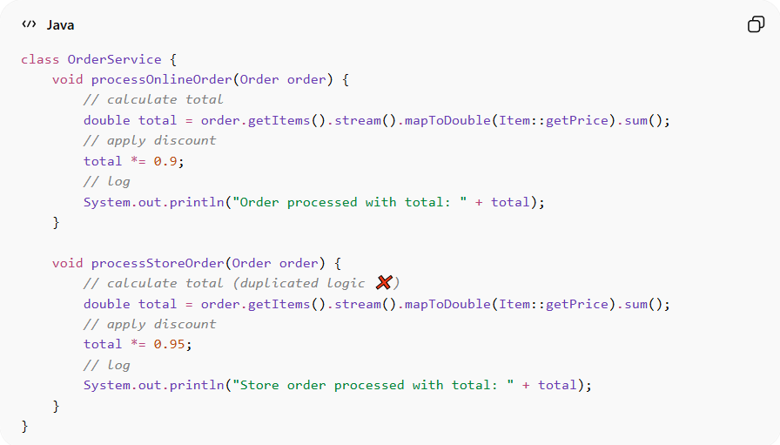
class OrderService {
void processOnlineOrder(Order order) {
// calculate total
double total = order.getItems().stream().mapToDouble(Item::getPrice).sum();
// apply discount
total *= 0.9;
// log
System.out.println("Order processed with total: " + total);
}

void processStoreOrder(Order order) {
// calculate total (duplicated logic ❌)
double total = order.getItems().stream().mapToDouble(Item::getPrice).sum();
// apply discount
total *= 0.95;
// log
System.out.println("Store order processed with total: " + total);
}
}
Problems:
• Duplicated logic for calculating totals
• Maintaining or updating calculation rules requires changes in multiple places
• Increases risk of bugs or inconsistencies

✅ Good Example
# Source: AI Source: Provided by: [Data Path: Persons Table -> ID Column: 1, Name_En Column: Motasem Essam] -> From: [ChatGPT] on [1/23/2026]
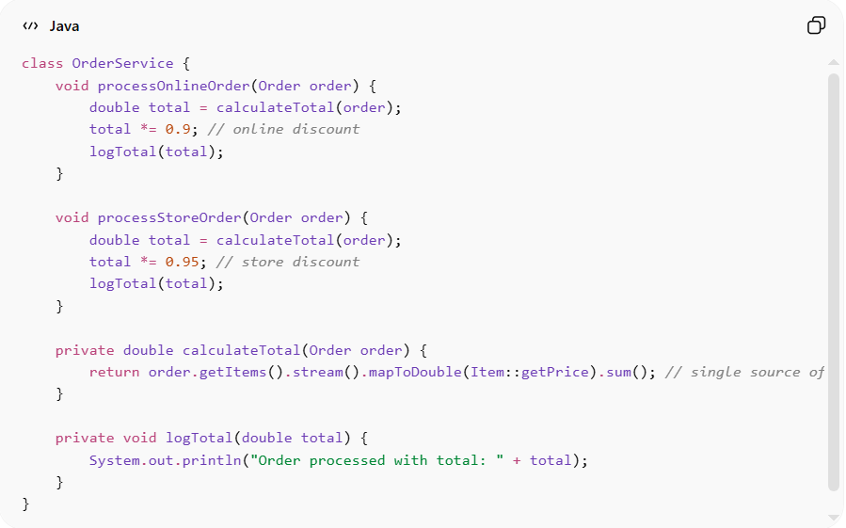
class OrderService {
void processOnlineOrder(Order order) {
double total = calculateTotal(order);
total *= 0.9; // online discount
logTotal(total);
}

void processStoreOrder(Order order) {
double total = calculateTotal(order);
total *= 0.95; // store discount
logTotal(total);
}

private double calculateTotal(Order order) {
return order.getItems().stream().mapToDouble(Item::getPrice).sum(); // single source of truth
}

private void logTotal(double total) {
System.out.println("Order processed with total: " + total);
}
}
Benefits:
• Logic exists in one place → easier to maintain
• Reduces bugs from inconsistencies
• Promotes reuse of code and modularity
• Supports maintainability and evolvability

⚡ When to Apply
# Source: AI Source: Provided by: [Data Path: Persons Table -> ID Column: 1, Name_En Column: Motasem Essam] -> From: [ChatGPT] on [1/23/2026]
• Always — avoid copying and pasting code
• Especially important in large projects with multiple developers
• Works best when combined with modular design and high cohesion
• Useful for functions, constants, configuration, and business logic

